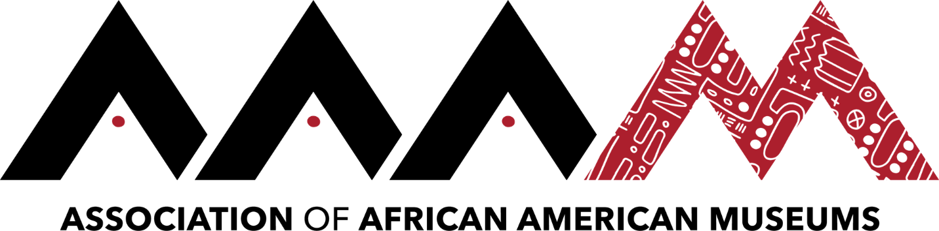
2019 Annual Conference | Jackson, Mississippi
Trenda Byrd
Click here to schedule your 15-minute Speed Networking Session
Trenda Byrd is the Assistant Director at the College Park Aviation Museum in College Park, MD which is part of The Maryland-National Capital Park and Planning Commission (M-NCPPC). Trenda Byrd is originally from Hickory, North Carolina and earned two undergraduate degrees from Appalachian State University in Boone, NC majoring in both History and Public History. After her matriculation at Appalachian Ms. Byrd moved to Baltimore, Maryland and attended Morgan State University where she earned my Master’s in Museum Studies and Historical Preservation with a focus in education.
Ms. Byrd started working at the College Park Aviation Museum in 2019. Ms. Byrd has an array of experience working in different types of museums, including the Banneker-Douglass Museum in Annapolis, MD, the Tubman Museum in Macon, GA, and Historic Brattonsville in McConnells, SC. Ms. Byrd also serves as a Board member for the Small Museum Association and is a Certified Interpretive Guide through the National Association of Interpreters.

