2019 Annual Conference | Jackson, Mississippi
Tamar Smithers
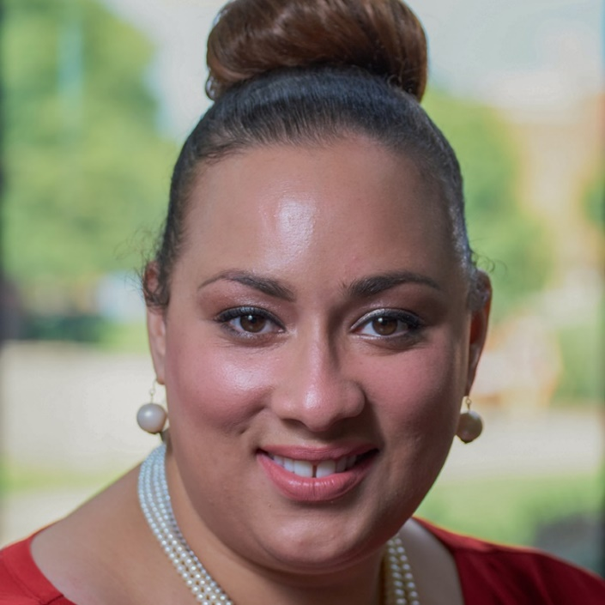
Click here to schedule your 15-minute Speed Networking Session
Tamar Smithers is a professional arts administrator and educator. She has over 10 years of experience in the arts administration and higher education field. As Director of Education and Public Programs for NMAAM she is instrumental in creating culturally specific programs and curriculum for all ages. In this role, she is committed to arts engagement and audience development both locally and nationally.
Tamar currently serves on AAAM’s Membership Committee. Tamar holds a BFA in Acting from Syracuse University as well as an M.S. in Arts Administration and C.A.S. in Higher Education Leadership from Le Moyne College. She has a true passion for mentoring and being a positive role model for our youth. Tamar is eager to encourage our young people to believe that no matter what their circumstances may be if they continue to pursue their dreams anything is possible!

