2019 Annual Conference | Jackson, Mississippi
Reverend Teddy R. Reeves
Click here to schedule your 15-minute Speed Networking Session
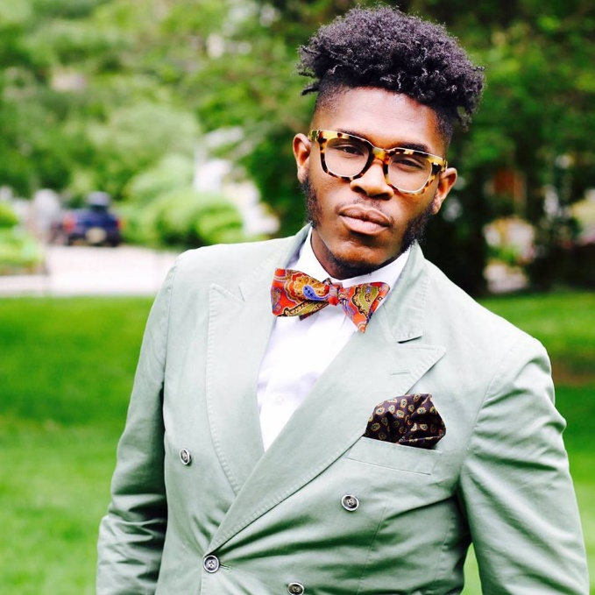
Reverend Teddy R. Reeves is the Curatorial Museum Specialist of Religion in the Center for the Study of African American Religious Life at the Smithsonian Institution's National Museum of African American History & Culture. At the museum, Teddy is responsible for assisting in collecting religious artifacts, research and scholarship, public programs, and faith based outreach.
Teddy previously served as the Executive Pastor at Calvary Baptist Church in Jamaica, NY. In addition, he served as the founding Program Administrator for the Center for Black Church Studies at Princeton Seminary, as a Teaching Assistant for the Pace Center for Civic Engagement at Princeton University, as a high school English teacher at two prestigious independent schools, and as a fundraising consultant for a large philanthropic firm.
Teddy earned his B.A. in English from Hampton University, Master of Divinity from Princeton Seminary, and is currently pursuing his Ph.D. in Administration & Supervision at Fordham University.

