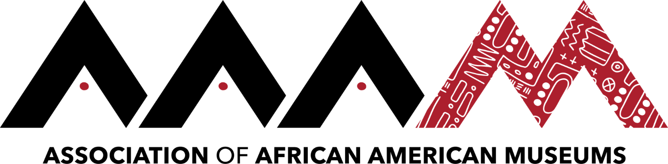
2019 Annual Conference | Jackson, Mississippi
Dr. Nicole Ivy
Click here to schedule your 15-minute Speed Networking Session

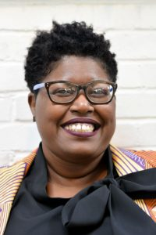
Nicole Ivy is a historical thinker and professional futurist who is passionate about the arts and social change. Her professional and scholarly interests include strategic foresight, public history, visual culture, and inclusive change management. She earned her B.A. in English from the University of Florida and her joint Ph.D. in African American Studies and American Studies from Yale University.
Having begun her work in the museum field as an Institute of Museum and Library Services (IMLS) Graduate Fellow at the African American Museum in Philadelphia, she has held several inaugural positions at the American Alliance of Museums, including serving as its first Director of Inclusion.
In addition to her work in the museum field, she has held numerous academic appointments. She was a Visiting Assistant Professor in the History Department at Indiana University, Bloomington (IUB) and a postdoctoral fellow of the Center for Research on Race and Ethnicity in Society (CRRES) at IUB. She is an Assistant Professor of American Studies at The George Washington University in Washington, D.C.

