2019 Annual Conference | Jackson, Mississippi
Dr. Maria T. Madison
Click here to schedule your 15-minute Speed Networking Session
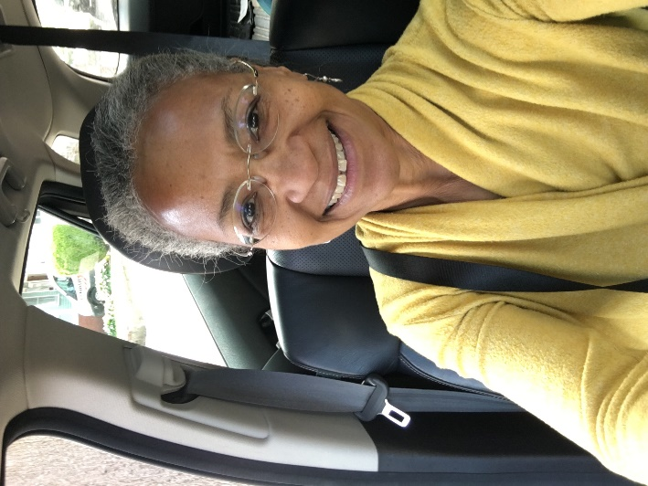

Dr. Madison is co president and founder of The Robbins House. The house and nonprofit commemorate the legacy of a previously enslaved Revolutionary War veteran and his descendants.

