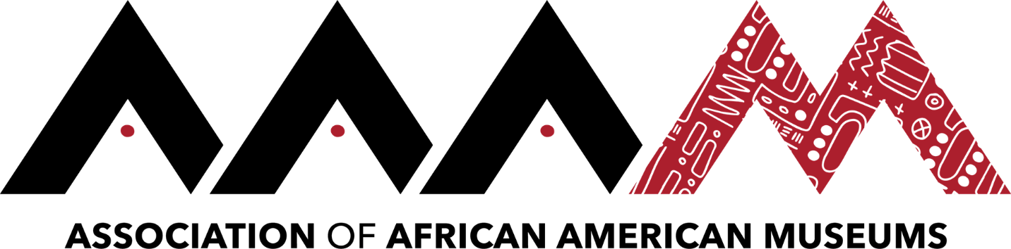
2019 Annual Conference | Jackson, Mississippi
LaNesha DeBardelaben
Click here to schedule your 15-minute Speed Networking Session
LaNesha DeBardelaben has spent her career in education and museum work. As a Michigan-native, she relocated to Seattle in December 2017 to serve as Executive Director of the Northwest African American Museum in Seattle. Under LaNesha’s leadership, NAAM is repositioning itself for accelerated growth. Prior, LaNesha was Senior Vice President at the Charles H. Wright Museum of African American History.
Her 15+ year career in museums began at the National Museum of Kenya in Africa, and she has studied museums and libraries internationally in Ghana, South Africa, England, Germany, and Israel. LaNesha serves on the boards of AAAM, ASALH, and the Seattle Metropolitan Chamber of Commerce. A graduate of the Jekyll Island Management Institute and Leadership Detroit, she has a BA in history and secondary education, MA in history and museum studies, MLS in archives management, MA in comparative black history, and is currently pursuing a PhD.

