2019 Annual Conference | Jackson, Mississippi
Joy L. Bivins
Click here to schedule your 15-minute Speed Networking Session
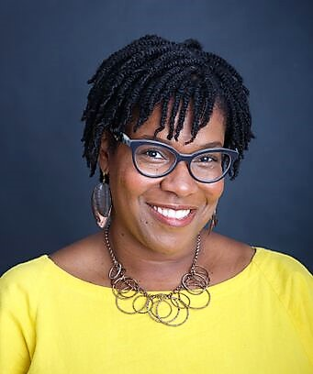
Joy L. Bivins is a museum professional with more than fifteen years of experience. She currently serves as Chief Curator of the International African American Museum in Charleston, South Carolina. Prior to that, she was the Director of Curatorial Affairs at the Chicago History Museum where she collaborated on numerous exhibition projects including Teen Chicago, Facing Freedom in America, Inspiring Beauty: 50 Years of Ebony Fashion Fair, and Amplified: Chicago Blues.
Bivins is co-editor the exhibition catalog Inspiring Beauty: Fifty Years of Ebony Fashion Fair and has contributed to the Journal of American History, Chicago History, and NKA: Journal of Contemporary African Art. A native Chicagoan, she holds a bachelor’s degree in Afro American Studies and History from the University of Michigan and a master’s degree in Africana Studies from Cornell University.

