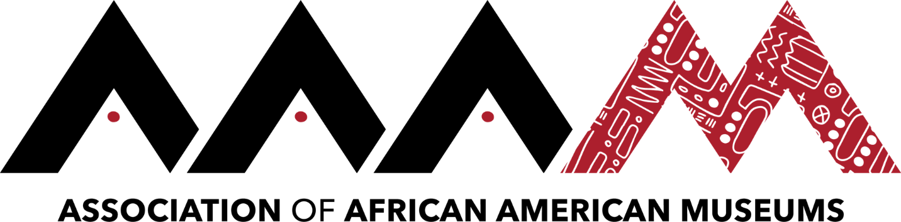
2019 Annual Conference | Jackson, Mississippi
Click here to schedule your 15-minute Speed Networking Session
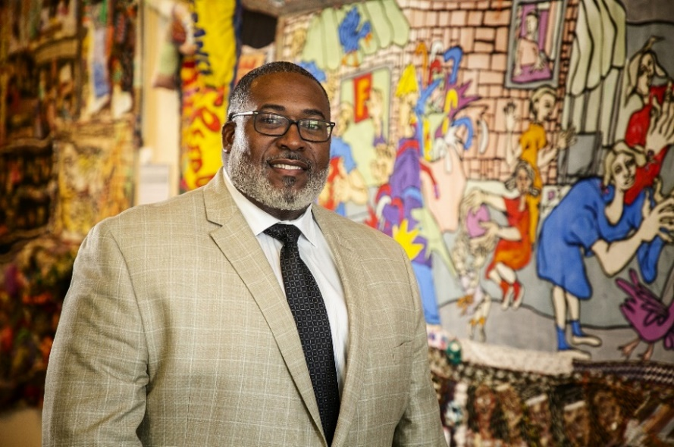
Christopher Miller
Christopher Miller is the Senior Director of Education and an accomplished museum professional at the National Underground Railroad Freedom Center in Cincinnati, Ohio. With more than 14 years of experience, his areas of expertise include historical research and interpretation, community engagement, educational initiatives, equity and inclusion, and public program development. Miller takes a leadership role in coordinating the institution’s work in building public awareness of history and advancing program initiatives related to social justice and cultural competency. Miller has served as an advocate for educating the public about the complete narrative of America through the lens of the African American experience.
He has written and performed history presentations that have universal appeal, while lecturing about the impact and value of history. Miller earned his M.A. in Public History from Northern Kentucky University in 2017, becoming the first African American male to graduate from the program and his B.A. in English from Northern Kentucky University in 2004. Before graduating Cum Laude from Northern Kentucky University, Miller earned a fellowship with the Institute for Freedom Studies where he served as a Research Assistant decoding antebellum runaway slave ads. Under the direction of Prince Brown, Jr., Ph.D., he assisted in developing a comprehensive database from primary source documents highlighting the attempts of enslaved persons to free themselves from state-sanctioned servitude.

