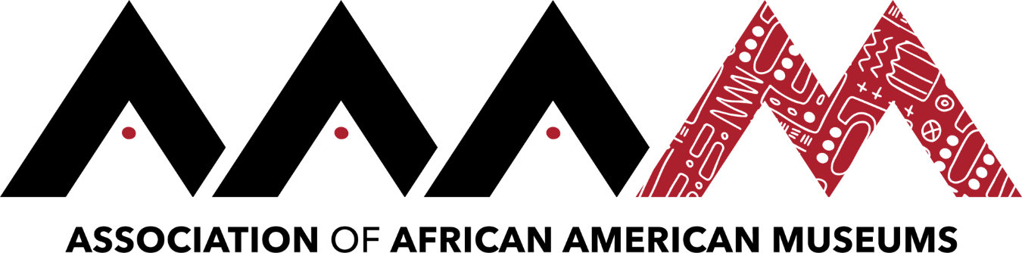
2019 Annual Conference | Jackson, Mississippi
Brent Leggs
Click here to schedule your 15-minute Speed Networking Session
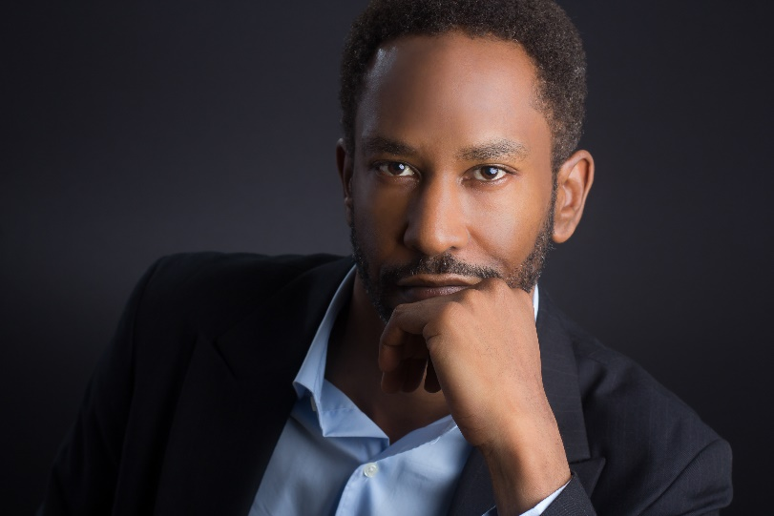

Brent leads a $25 million fundraising and preservation initiative to help preserve 150 sites of Black activism, achievement, and community. During his 15-year career, he has led national campaigns to honor the American Civil Rights Movement, women’s history, arts and culture, and more. His expertise is strategic and master planning, social and ethnic issues, fundraising, partnership development, and branding.

